New Patient Registration Form

Date & Time of Registration Appointment:
You are welcome to join our patient list at St. George’s Medical Centre (SGMC).

Please note: -

- Anyone over the age of 16 will need to come to the surgery to register in person
- If you are registering a baby the mother of the baby must be registered at SGMC as well
- You must be living in the SGMC catchment area and living there permanently
- By registering with SGMC you consent to SGMC contacting you by any means, including digitally

You will need to complete all the attached forms and arrange an appointment to come in to register.

Please also bring with you the following 5 things: -

- Photo ID (e.g. passport, driving license or ID card)
- Proof of current address (e.g. bank statement, utility bill, tenancy agreement, council tax bill – must be dated within the last 3 months)
- Your NHS number or NHS medical card – previous hospital letters may have this information
- The name and address of your previous GP practice
- Your previous address

Use the checklist below to ensure you have everything that is needed.

 | Yes | No
Has this form been completed?
Photo ID?
Proof of current address?
NHS number or NHS medical card?
Name and address of previous GP practice?
Your previous address?

Once you have been registered onto our computer system, you will be invited to a New Patient Health Check appointment with a nurse. This is so we can understand how we can best support your health needs efficiently and effectively
About You

Title |  |  | Current Address and postcode
Surname
Previous Surname*
Forename(s)
Date of Birth |  |  | Home Phone
Gender |  |  | Work Phone
NHS NUMBER |  |  | Mobile
Town and country of birth |  |  | Email | Email
Date arrived in UK
Main spoken language
Do you need an interpreter?

* If applicable
We will mainly use your mobile and email to contact you. It is your responsibility to let us know if you change your mobile phone number or email address.

Please help us trace your previous medical records by providing the following information:

Your previous address in UK | Name and address of previous GP practice whilst at this address

If you are from abroad:
Your first UK address where registered with a GP | If previously resident in the UK, which date did you leave?

Children

If you have any children (under 16) who you wish to register at SGMC please provide their information below: -

Please remember to circle if Male or Female

 | NAME |  | Date of birth |  |  | NHS  Number | Previous GP Surgery | Town and country  of birth | Date Arrived  in the UK*
Child 1
M/F
Child 2
M/F
Child 3
M/F
Child 4
M/F
Child 5
M/F
Child 6
M/F
* If applicable

Ethnicity

Having information about patients’ ethnic groups would be helpful for the NHS so that it can plan and provide culturally appropriate and better services to meet patients’ needs.

If you do not wish to provide this information you do not have to do so.

Please indicate your ethnic origin by ticking the below box:

White | English / Welsh / Scottish / Northern Irish / British
 | Irish
 | Gypsy or Irish Traveller
 | Any other White background
Mixed / Multiple  ethnic groups | White and Black Caribbean
 | White and Black African
 | White and Asian
 | Any other Mixed / Multiple ethnic background
Asian / Asian British | Indian
 | Pakistani
 | Bangladeshi
 | Chinese
 | Any other Asian background
Black / African / Caribbean / Black British | Africa
 | Caribbean
 | Any other Black / African / Caribbean background
Other ethnic group | Arab
 | Any other ethnic group

Next of kin

Title
Surname
Forename
How are you related?
Emergency Contact Information
Telephone
Mobile
Email

Service Families and Military Veterans

As a practice, we fully support the Armed Forces Covenant. We can only do this if we know our patients connections to the Armed Forces. Please tick the below boxes that apply to you:

I AM a Military Veteran |  | I AM currently serving in the Reserve Forces
I AM married/civil partnership to a serving member of the Regular/Reserve Armed Forces |  | I AM married/civil partnership to a Military Veteran
I AM under 18 and my parent(s) are serving member(s) of the armed forces. |  | I AM under 18 and my parent(s) are veteran(s) of the armed forces.

Carer status

Do you have a carer? (Y/N)
If yes, please give details of their name, relationship and whether they are a patient here too.

Are you yourself a carer? (Y/N)
If yes, please also register with Barnet Carers: 020 3995 1909 / admin@barnetcarers.org

Power of Attorney

Does anybody hold Lasting Power of Attorney for Health and Welfare for you? (Y/N)
If yes, please supply details of who holds this and where (and supply a copy for your medical notes)

Summary Care Record (SCR)

Name: |  | Date of Birth:

If you decide to have a SCR, it will contain important information about any medicines you are taking, allergies you suffer from and any bad reactions to medicines that you have had it will also include basic information about your current diagnoses. Giving healthcare staff access to this information can prevent mistakes being made when caring for

For more information: Phone 0300 123 3020 or visit www.nhscarerecords.nhs.uk

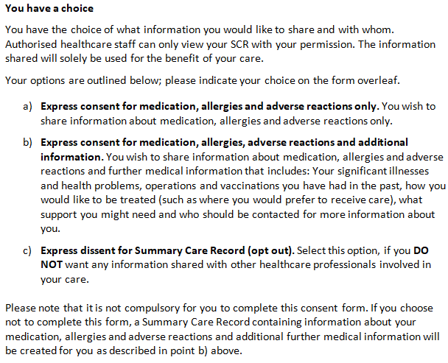

Yes – I would like a Summary Care Record (tick one of two options below): -
- Express consent for medication, allergies and adverse reactions only.
or
- Express consent for medication, allergies, adverse reactions and additional information.
No – C) I would not like a Summary Care Record (opt out)

N.B. If you opt out, this will mean NHS Healthcare staff caring for you may not be aware of your current medications, any allergies or reactions to previous medication.

SUPPLEMENTARY QUESTIONS - These questions and the patient declaration are optional and your answers will not affect your entitlement to register or receive services from your GP.

PATIENT DECLARATION for all patients who are not ordinarily resident in the UK

Anybody in England can register with a GP practice and receive free medical care from that practice.
However, if you are not ‘ordinarily resident’ in the UK you may have to pay for NHS treatment outside of the GP practice. Being ordinarily resident broadly means living lawfully in the UK on a properly settled basis for the time being. In most cases, nationals of countries outside the European Economic Area must also have the status of ‘indefinite leave to remain’ in the UK.
Some services, such as diagnostic tests of suspected infectious diseases and any treatment of those diseases are free of charge to all people, while some groups who are not ordinarily resident here are exempt from all treatment charges.
More information on ordinary residence, exemptions and paying for NHS services can be found in the Visitor and Migrant patient leaflet, available on the NHS.UK website.
You may be asked to provide proof of entitlement in order to receive free NHS treatment outside of the GP practice, otherwise you may be charged for your treatment. Even if you have to pay for a service, you will always be provided with any immediately necessary or urgent treatment, regardless of advance payment.
The information you give on this form will be used to assist in identifying your chargeable status, and may be shared, including with NHS secondary care organisations (e.g. hospitals) and NHS Digital, for the purposes of validation, invoicing and cost recovery. You may be contacted on behalf of the NHS to confirm any details you have provided.
Please tick one of the following boxes: -
 | A | I understand that I may need to pay for NHS treatment outside of the GP practice
 | B | I understand I have a valid exemption from paying for NHS treatment outside of the GP practice. This includes for example, an EHIC, or payment of the Immigration Health Charge (“the Surcharge”), when accompanied by a valid visa. I can provide documents to support this when requested
 | C | I do not know my chargeable status

I declare that the information I give on this form is correct and complete. I understand that if it is not correct, appropriate action may be taken against me.
A parent/guardian should complete the form on behalf of a child under 16.
Signed: |  | Date:
Print Name: |  | Relationship to patient:
On behalf of:

Complete this section if you live in another EEA country, or have moved to the UK to study or retire, or if you live in the UK but work in another EEA member state. Do not complete this section if you have an EHIC issued by the UK.

NON-UK EUROPEAN HEALTH INSURANCE CARD (EHIC), PROVISIONAL REPLACEMENT CERTIFICATE (PRC) DETAILS and S1 FORMS

Do you have a non-UK EHIC or PRC?
Yes |  |  | No

If yes, please enter details from your EHIC or PRC below:
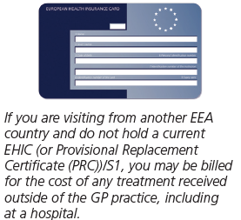 | Country Code:
 | Name:
 | Given Names:
 | Date of Birth:
Personal Identification
Number
Identification number
of the institution
 | Identification number of the card
 | Expiry Date
PRC validity period (a) From: |  | To:
Please tick if you have an S1 (e.g. you are retiring to the UK or you have been posted here by your employer for work or you live in the UK but work in another EEA member state). Please give your S1 form to the practice staff.
How will your EHIC/PRC/S1 data be used? By using your EHIC or PRC for NHS treatment costs your EHIC or PRC data and GP appointment data will be shared with NHS secondary care (hospitals) and NHS Digital solely for the purposes of cost recovery. Your clinical data will not be shared in the cost recovery process.
Your EHIC, PRC or S1 information will be shared with The Department for Work and Pensions for the purpose of recovering your NHS costs from your home country.

